Appendix 2
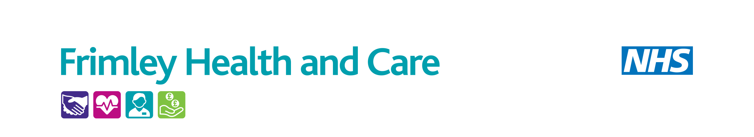
Template for Care Home staff for Reporting and Learning from a medicine-related Patient Safety Incident (PSI) (error/ incident/ near miss/ concern)
PART 1: REPORTING a MEDICINE-RELATED PSI
Name and organisation of person completing this form: |  | Date form completed:
Name & organisation of person identifying error/ incident/ near miss/ concern
Date medication error/ incident/ near miss/ concern took place: |  | Date Incident Identified:
Location of Incident:
Own Home | Residential Care Home |  | Nursing Home
Learning Disability Home | Supported Living |  | Out of Hours Centre
GP practice | Community Hospital |  | Community Pharmacy
Other (please describe) ..................……………………………...
Type of medication error
Error |  | Incident
Near miss |  | Concern
Stage of medication process:
Documentation/ communication | Prescribing |  | Administration
Dispensing | Monitoring |  | Advice
Other (please describe) ..............................................................

Name of medication(s) involved:
Description of medication error / incident/ near miss/ concern. What happened?
Resident Date of Birth: |  |  | Sex: | Male Female Not stated / unknown
Ethnicity of Resident:

White |  | Black or Black British |  |  | Mixed
Asian or Asian British |  | Other |  |  | Not stated / unknown
What was the actual effect on the resident and/ or service?
Action taken at the time of the medicines-related event
 | PART 2: LEARNING from a MEDICINE-RELATED PSI |  | Date of meeting
 | What could have been done better?
 | What went well?
 | Key risk issues identified:
 | Lessons learned:
 | Names and organisations of persons present at meeting:
 | Date to review actions:
 | Care Home to return completed form to NHS Frimley MOCH Team via email: frimleyicb.moch@nhs.net
Care Home Medicines Safety Champion contact name and email address:

Please tick here if you consent for any learning from this event to be shared:

For completion by Medicines Optimisation in Care Homes (MOCH) Team only
What impact or potential impact did the event have on the patient?
Degree of harm to the patient (severity) | Potential Harm | Actual Harm
- None
- Low Harm (patient(s) required extra observation or minor treatment)
- Moderate Harm (patient(s) required further treatment, or procedure)
- Severe Harm (permanent or long-term harm)
- Death (related to the incident)

