Food and Drinks Chart
- Start a food and drinks chart each day per resident.
- Each time they have a drink at the structured drinks round or more – ensure that it is documented below. Each time they eat ensure it is completed below.
Name of resident: |  |  |  |  | Date of  Birth: |  |  |  | Date: |  |  |  |  | Room Number:
Time | What type of drink?  Tea/Juice/Water  What type of food?  Porridge, scrambled egg |  | Drinks - Type of cup or glass used? |  |  |  |  |  | How much was eaten/drunk?
Time |  |  | Teacup  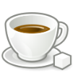  150mls | Mug  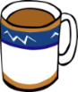  200mls |  | Small  glass  200ml |  | Beaker  200mls  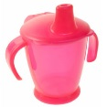 | Drank/ ate none |  | Drank/ ate a little  25% | Drank/ ate  half  50% | Drank/ ate most  75% | Drank/ ate all  100% | Total in mls | Running total | Initials
Comments:

