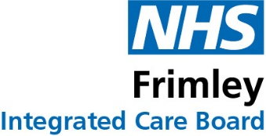

Anti-Fraud, Bribery and Corruption, Money Laundering and Economic Crimes Statement
NHS Frimley ICB is committed to eliminating fraud, bribery and corruption, money laundering and other economic crimes within the NHS to protect public resources for health and care.
Fraud is an act of deception that is intended to make a financial gain or to cause a loss to another party. Bribery is generally defined as the giving or receiving of a financial or other advantage in exchange for improperly performing a relevant function or activity.
The ICB employs a specialist counter-fraud service to provide a comprehensive programme against fraud, bribery and corruption which is overseen by our Chief Finance Officer and the Audit Committee.
The ICB has a zero-tolerance approach to fraud, bribery and corruption, money laundering and other economic crimes and is committed to applying the highest standards of ethical conduct and behaviour, as well as having robust controls in place to prevent these. As well as staff, the ICB also expects its suppliers and contractors to adhere to the same high standards.
Our dedicated policies and procedures set out our expectations and guidance for staff, contractors and anyone else working with or for the ICB with regards to preventing fraud, bribery and corruption, money laundering and other economic crimes and raising concerns.
We ask all who have dealings with the ICB, as employees, agency staff, trading partners (contractors/suppliers), stakeholders and patients, to help us in our fight against fraud, bribery and corruption and to contact us immediately if any concerns arise. No individual will suffer any detrimental treatment as a result of reporting reasonably held suspicions. The success of the ICB’s anti-fraud, bribery and corruption measures depends on everyone playing their part.
The ICB contracts TIAA Ltd to provide its counter fraud service and you can contact our Counter Fraud Specialist, Arti Scott, Anti-Crime Manager in confidence:
- by e-mail arti.scott@tiaa.co.uk or arti.scott1@nhs.net
- or by phone on 07795 044 114
All genuine suspicions of fraud, bribery or corruption can also be reported in confidence to the NHS Fraud and Corruption Reporting Line on free phone 0800 028 40 60 or at: https://cfa.nhs.uk/reportfraud

Rich Chapman
Chief Finance Officer

